3.12: Time to fall 9.00 m from rest:
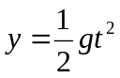
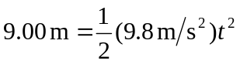
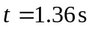

Speed to travel 1.75 m horizontally:
